Unit 1 I Kickstart My Chart
Kickstarter Project Report
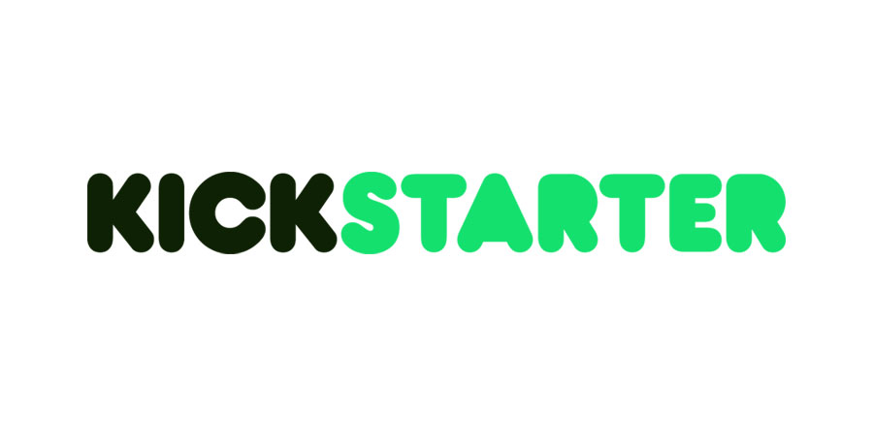

Prepared By:
Sylvain David

June 15, 2020
Table of Contents:

List of Figures and Tables p.3
Introduction p.4
Part 1: What are three conclusions possible about Kickstarter campaigns? p.5
Part 2: What are some of the limitations of this dataset? p.10
Part 3: What are some other possible tables and/or graphs? p.10
Part 4: Analysis of the dataset (Bonus) p.11

List of Figures and Tables:

Figure 1: Count of state by category p.5
Figure 2: Count of state by sub-category p.6
Table 1: Music genres preferred by consumers in the United States in 2018 p.7
Figure 3: Count of state by date p.8
Figure 4: Count of state by fundraiser goal p.9
Table 2: Summary statistics table p.11

Introduction:

Over $2 billion has been raised using the massively successful crowdfunding service, Kickstarter, but not every project has found success. Of the more than 300,000 projects launched on Kickstarter, only a third have made it through the funding process with a positive outcome.
Getting funded on Kickstarter requires meeting or exceeding the project's initial goal, so many organizations spend months looking through past projects in an attempt to discover some trick for finding success. For this week's homework, you will organize and analyze a database of 4,000 past projects in order to uncover any hidden trends.

Part 1: What are three conclusions possible about Kickstarter campaigns?
From 2009 to 2017, 54% of the Kickstarter campaigns were more likely to be successful than to fail at 38% or get cancel at 8%. This the overall summary we can see when we study the dataset given. However, these numbers don’t reflect several conclusions that could be made about these campaigns.
Some categories are more likely to succeed than others
When we look at the Figure 1, four major categories see more campaigns. The theater has 1393 campaigns, music has 700 campaigns, technology has 600 campaigns when film and videos have 520. If we put aside the technology category, because 65% of the campaigns are either canceled or failed, the three other categories have a better chance to succeed.

Figure 1: Count of state by category
Music category has the highest success rate of 79%, which represent 25% of all successful campaigns through all nine categories in all countries.
Then there is the theater category who comes with a successful rate of 61% and a total of 38% of all nine category in successful campaigns. By far is the largest category with 1393 campaigns, which is 34% of all campaigns in all nine categories. If music is more global, the theater campaign demonstrates geographical sensitivity especially in Great Britain and France with a higher successful rate.
Last but not least, we have the film and video rubrics, which comes third with a success rate of 58% of 520 campaigns. This category has the same aspect as the theater in it is geographically sensitive with the United States having the most successful campaigns.
Some trends within these categories
As we mentioned in the categories’ analysis, the theater, geographically sensitive, has a huge importance in the successful campaign by number: 1047 and ratio 66% of success. It is interesting to focus on the subcategories of the new technologies and the music, both having total opposite success (Figure 2).

Figure 2: Count of state by sub-category

The technology category, which regroups video games, web, animation, space exploration, doesn’t have a such success even though we are at a crossroad currently. This lake on engagement in funding campaigns is because most the investment is done by companies. In a 2019 survey, KPMG’s result show that 84% of start-up, 59% of mid-market and 40% of large enterprises invest 0 to 9.9 million dollars. A survey like this could then explain why there is no such room for success in the technology category with a 100% failure or cancelation.
Music is widely and globally successful with a 100% rate for the sub-category in classical music, electronic music, metal, pop, radio podcasts, rock. Only the Jazz has a 100% failure rate. We might explain this result by the independent labels and the popularity of the music genre. Independent record labels don’t have the budget of big label such as Sony or Universal. In 2017, a study showed the independent labels represented 39.9% of all the music industry. The increasingly number of independent labels could be one of the reasons why Kickstarter campaigns would be so popular and successful.
All the music categories have a real success except the jazz when comes fundraiser campaigns. One of the reasons is Jazz come only in seventh position in a survey made in 2018 on Music genres preferred by consumers in the United States.
Music genre | Percentage of population
Rock | 56.8%
Pop | 56.1%
Country | 49.9%
R&B and Soul | 38.9%
Hip Hop | 37.4%
Easy Listening | 32.7%
Electronic/dance | 20.6%
Jazz | 20.2%
Table 1: Music genres preferred by consumers in the United States in 2018
We can conclude there is a correlation between the position of the jazz in this survey and the number and success rate of the Kickstarter’s campaigns.
There is a time for funding
When we look at the Figure 3, we can observe several interesting movements in the lines of the graph.

Figure 3: Count of state by date

First of all, analysis shows the highest success rate is in May at 61% across all categories with the lowest point in December with a 44% success rates.
Secondly, we can see the gap between successful and failed closes all year long and cross in December. We can conclude that even though the successful campaigns look above the failed campaigns, it slowly goes down from 183 to 111 campaigns. From May to December we have a 48% decline in successful campaigns (goes from 213 to 111 successful campaigns) and only a 6% decline in failed campaigns, which explains why the two lines cross in December.
One main reason on why such results is the economical situation of the people who gives the money. January to May we see an increase because the new year good resolution effect as well as the tax return period, which most of the time result in a refund from the government. Then comes the summer from May to September, when people spend more money in leisure and vacations. We can see a small spike because of the thanksgiving and pre-Christmas period, where giving is in the air and we don’t count the expenses to make someone else happy. Then come December, when family’s budgets are tight.
To conclude this part, we can definitely observe that three main categories dominates the campaigns: music, theater and film/video. We can also show that there is a certain period of the year to start a campaign: January to May. We could also focus on the amount needed to be raised and the rates of success and fails i.e. the more money is asked the more chance you have to failed to collect this amount (Figure 4).
Figure 4: Count of state by fundraiser goal

Part 2: What are some of the limitations of this dataset?
I can see two limitations of this dataset: geography, demographics. We do have a dataset at an international level, which is good but a more regional or local one would have been a plus to study the trends. It would be great, for example, to compare different parts of the United States. Most of the time people compare to what they are know or familiar to. Comparing the theater category would be more relevant if it was between the West Coast and the East Coast rather than between France and the United States; Both countries don’t have the same approach to culture because of their history, society etc.
The demographics could have a better focus in this dataset. Knowing the income household as well as the age could help figure out how to be more successful in a Kickstarter campaign. For example, if you want to start a fundraiser on jazz, it would be great to know from past campaigns the age: do we reach out to young people or 50-60 year old? The city/region: do we target more people from the big city or rural part of the country? The income: Do we target people with an average salary or high income?

Part 3: What are some other possible tables and/or graphs?
We have been focusing mainly on the category, the time and the amount goal. With the same set of data, it would be great to create a graph that show the length of a campaign and his success rates. Would it be more successful to have a short but intense campaign or a long a easy ride campaign to reach the goal?
Another interesting graph would be to see how the number of donators, the goal and the average donations would be related all together. In this case we could see if the number of backers or the goal or the average is more important or work well together.

Part 4: Analysis of the dataset (Bonus)
After isolating the successful and failed campaign, it was possible to calculate the median,

State | Median | Mean | Min | Max | Variance | Standard Deviation
Successful | 62 | 194.4251716 | 1 | 26457 | 712840.9867 | 844.2991098
Failed | 4 | 17.70980392 | 0 | 1293 | 3773.221669 | 61.42655508
Table 2: Summary statistics table
the mean, the minimum, the maximum, the variance and the standard deviation. After calculation, it looks like the median summarizes the data more meaningfully than the mean. The outliers in successful campaigns, which is 26457 skew the mean and doesn’t give a precise picture of the dataset.

Source : https://assets.kpmg/content/dam/kpmg/us/pdf/2019/06/investment-in-technology-innovation-2019.pdf
Source : https://www.midiaresearch.com/blog/independent-labels-grew-global-market-share-to-39-9-in-2017
Source: https://www.statista.com/statistics/442354/music-genres-preferred-consumers-usa/

